Assignment Question
BCA(hons.)-ll Sem
Bca- 204 Open Source Operating System

-------------------------------------------------------------------------------------------------------------------------------------------

Date 6-9-21

Q20 What is interacting process?
Q21 What are various operation on the process?
Q22 What is multi thread?
Q23 discuss the advantage of multi thread?
Q24 Difference between process and thread?

Date 21-9-21

Q25 Differentiate between scheduler type?
Q26 Explain IPC communication?
Q27 What is critical section explain? Q28 explain in brief ‘Semaphores’?
Q29 explain in brief ‘Monitor’?
Q30 What are Mutex?
Q31 Explain structure of concurrent processor?
Q32 Explain type of scheduler (preemptive / non preemptive)?
Q33 Define context switching?
Q34 Explain FCFS(characteristics, advantage , disadvantage, one-example)
Q35Explain SJP(characteristics, advantage , disadvantage, one-example)
Q38 Explain SRTF(characteristics, advantage , disadvantage, one-example)
Q39 Explain Priority(preemptive ,non preemptive, advantage , disadvantage, one-example) .
Q40 Explain ROUND ROBIN(characteristics, advantage , disadvantage, one-example)
Q41Explain multilevel queue scheduling ?
Q42. Solve the following question given in image below:

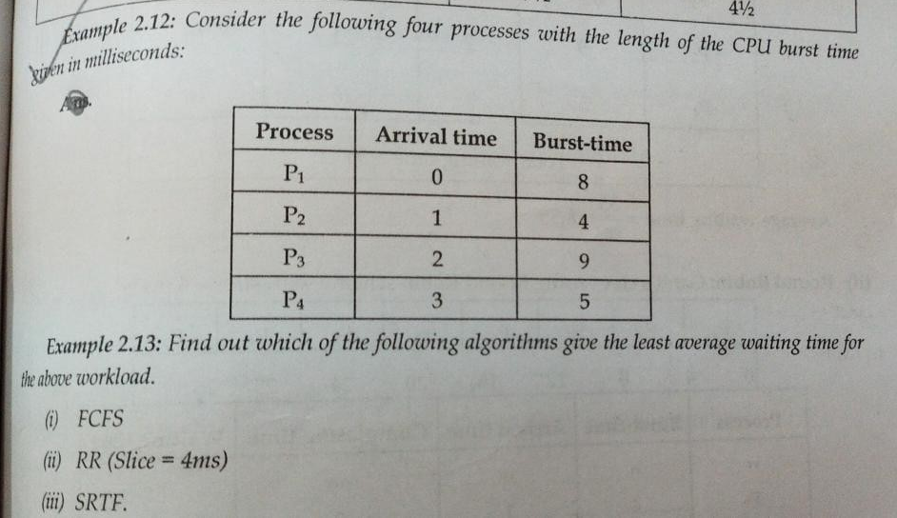
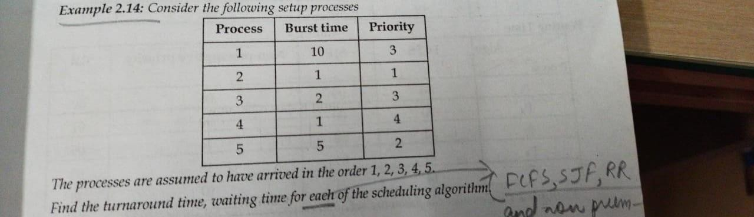
Q44.
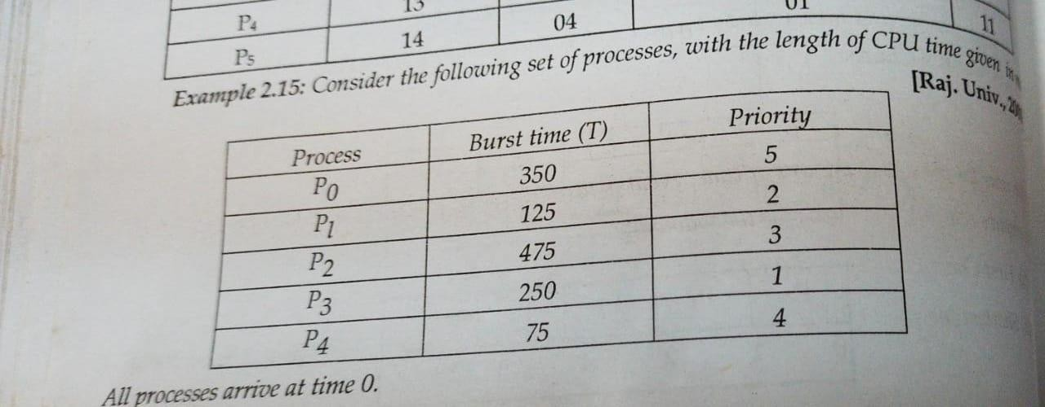

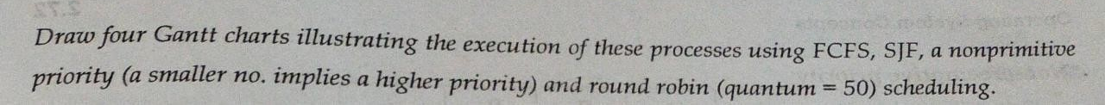
Q45
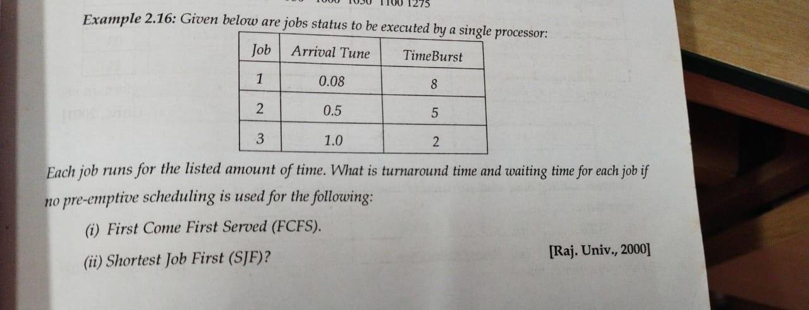

Q46
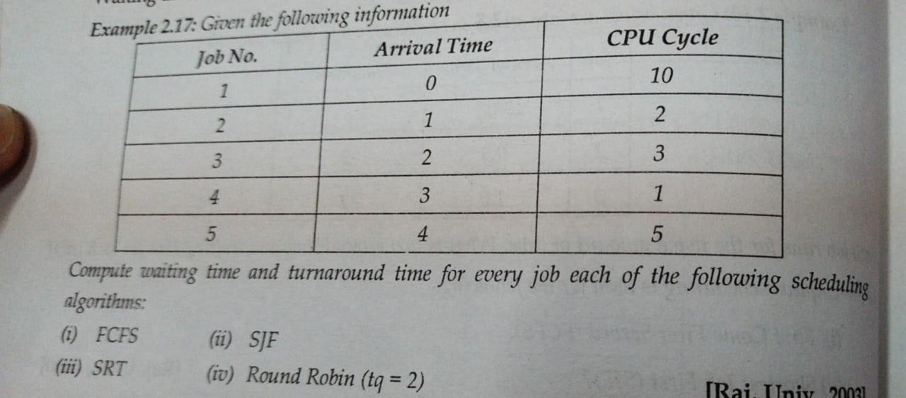
Q47
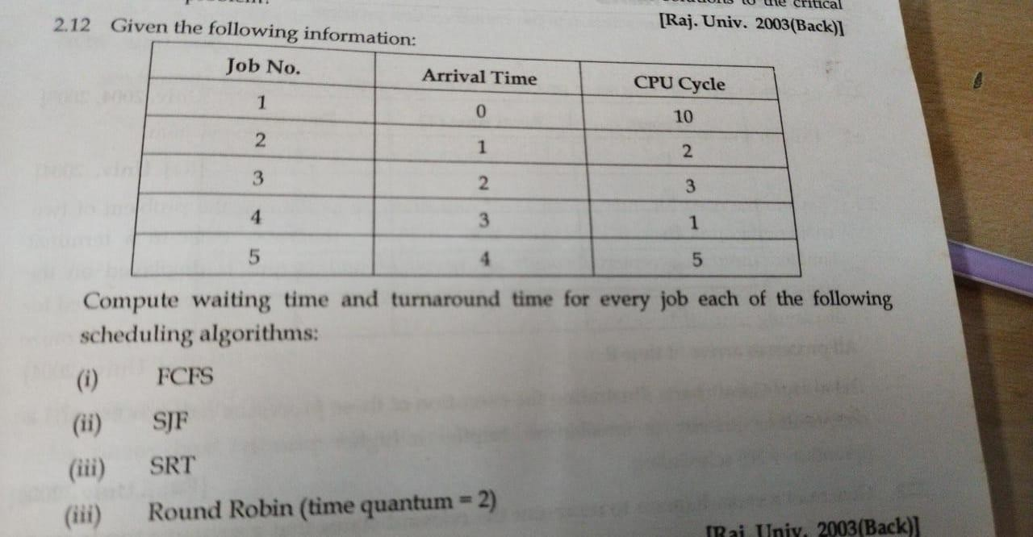
Q48
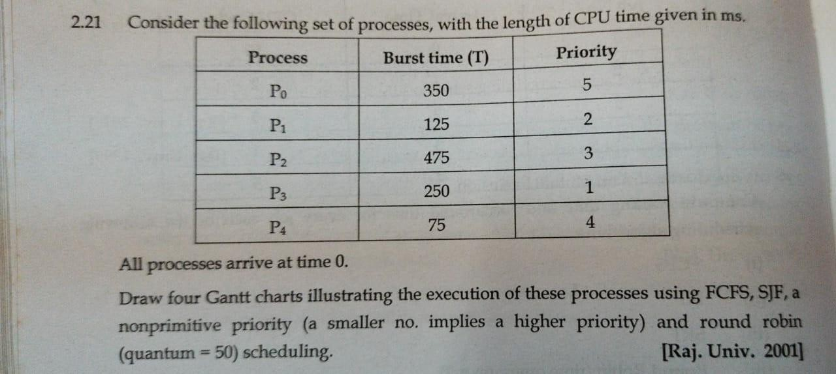

Q49
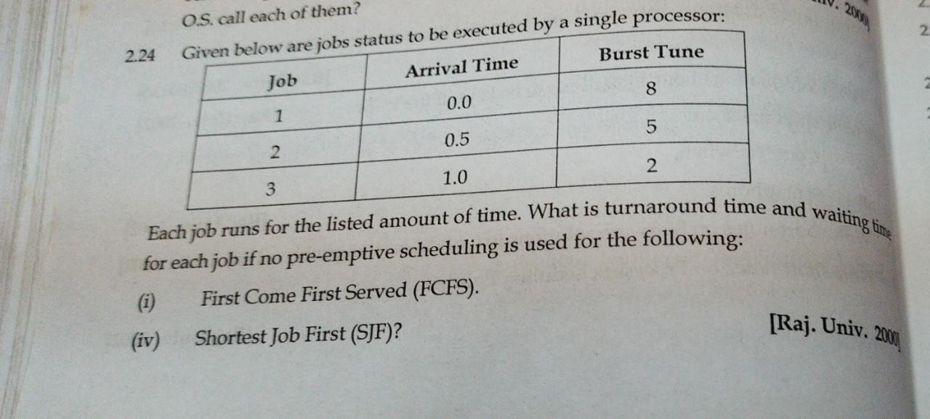
Q50 Draw the Gantt chart and calculate the Average Waiting Time and average turn Around Time for the following:
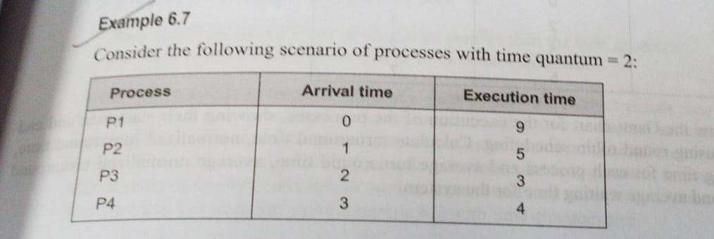
Q51 Draw the Gantt chart and calculate the Average Waiting Time and average turn Around Time for the following:
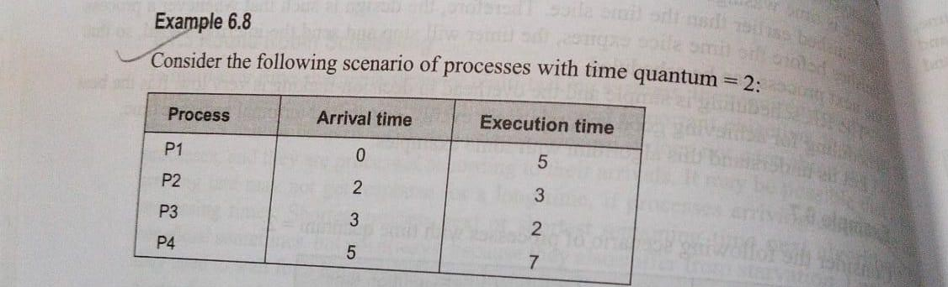

Q52 Draw the Gantt chart and calculate the Average Waiting Time and average turn Around Time for the following:
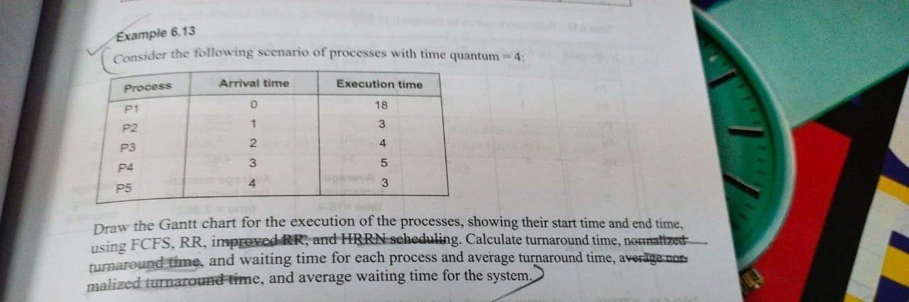
Q53 Draw the Gantt chart and calculate the Average Waiting Time and average turn Around Time for the following:
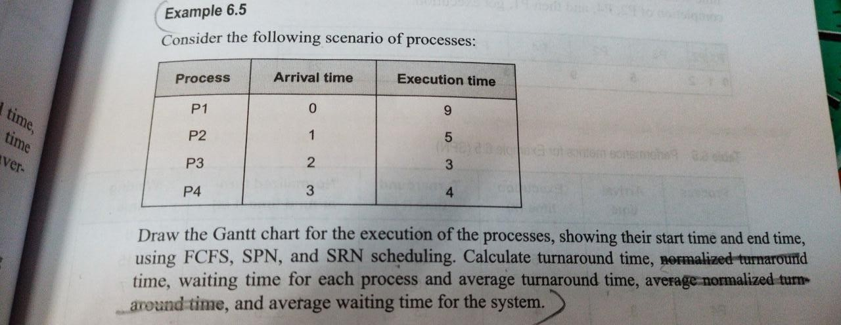
Q54 Draw the Gantt chart and calculate the Average Waiting Time and average turn Around Time for the following:
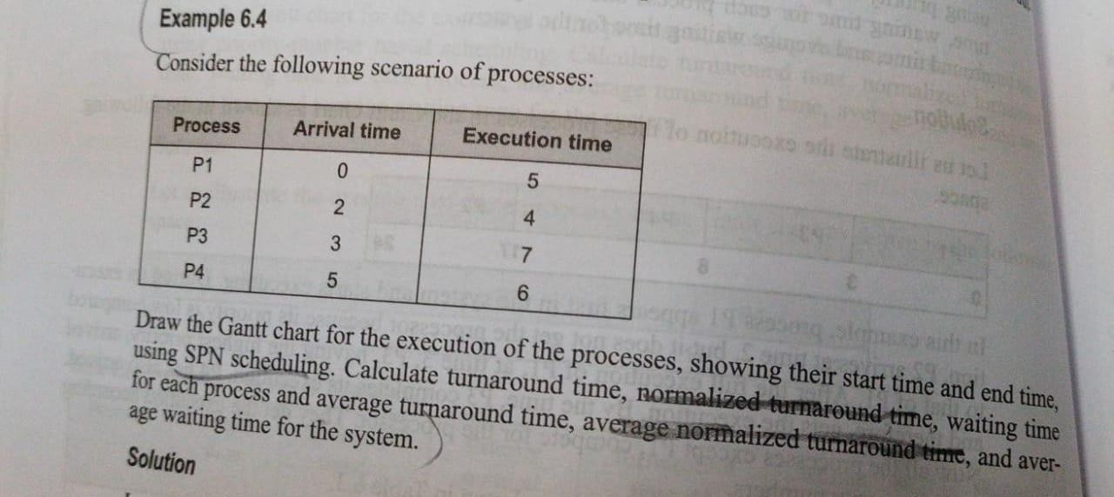

DATE 22-9-21
Q55 what is deadlock?
Q56 explain modelling of deadlock(RAG)
Q57 in a system the following state of processes and resources are given

P1->R1 , P2->R3 , R2->P1 ,R2->P3 ,P4->R3 ,R1->P4
Q58 In a system the following state of processes and resources are given

R1->P1, P1->R2 ,P2->R3 ,R2->P2 ,R3->P3 ,P3->R4 ,P4->R3 ,R4->P4 ,P4->R1 ,R1->P5

